|  |  |  |
| --- | --- | --- |
| Some areas have well managed farms and small holdings | Some developments are well sited and landscaped such as business parks | Some services such as reservoirs (stores of water) or cemeteries, may be attractive. |
| Transport and Infrastructure | Urban services | Some cycle ways improve access and promote new development |
| Some developments such as out of town malls cause serious pollution. Many businesses are unregulated e.g. scrap metal | Mineral workings, sewage works, landfill sites (for trash) are services which are needed but can be unattractive and polluting. | Farmers often suffer from litter, trespassers and vandalism; some land is derelict in the hope that planning permission for development will be granted. |
| Motorways destroy countryside, especially near junctions. | Country parks, sports fields and golf courses can lead to conservation. | Some sports can have a negative effect on the environment. |
| Recreation and sport | Agriculture | Landscape and nature conservation |
| Development | Conservation area may be included at the edge of the city | There may be degraded land e.g. land ruined by fly tipping (dumping of rubbish). Many conservation areas are under threat. |

**Lesson 7: Features of urban areas**

**Aim:** to identify the different features of urban areas

**Task 1: Connect the land use with the positive or negative statement – Issues in the urban fringe (edge of urban areas)**

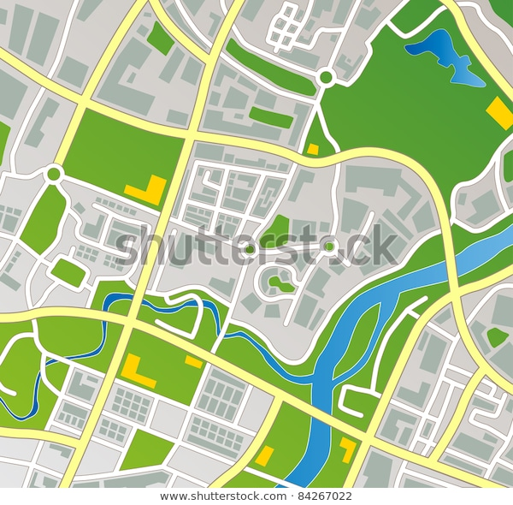

**What are the features of urban areas?**

Rural/Urban Fringe facts:

-some pressures on the rural-urban fringe are urban sprawl, more housing and industrial growth.

-the nature of the pressure depends on the type of urban fringe (area of growth/area of decline)

Growth of out of town shopping centres:

- the retailing revolution has focused on superstores like hypermarkets and out of town shopping centres.

-the increasing use of out of town shopping centres and trend for less frequent shopping has lead to the closure of many small shops.

Transport Routes:

-characterised by small, congested roads

-the volume of traffic for the roads is too great

- the edge of town there are larger motorways and ring roads.

Open Spaces:

-the number of open spaces increase towards the edge of town

-related to areas that are next to rivers

Industry facts

-traditional inner-city areas close to railways or canals

-need skilled labour (e.g., medical instruments)

-areas with good land accessibility

Task 3: What are the advantages and disadvantages of out of town shopping centres?

|  |  |
| --- | --- |
| Advantages | Disadvantages |
| - plenty free parking  -lots of space, shops aren’t cramped  -easily accessible by cars  -new developments so its attractive  -shops sell large amounts of goods/ lower prices.  -individual shops are larger so can offer greater range of goods.  -land price is lower at the edge  -developments on the edge reduce environmental pressures  -many jobs can be created in construction and retail industry. | -they destroy large amounts on developed Greenfield sites  -Destroy valuable habitats  -many jobs are unskilled |

**Complete the activities on P58**

1. Plenty free parking
2. **People in the suburbs, because developments on edge of town reduce the environmental pressures and problems in city centres**
3. A)CBD urban services b) agriculture c) landscape conservation d)industrial because selling